Setting up local git repository for Windows

1. Download and install GiHub Desktop <https://desktop.github.com/>
2. Launch Git Shell:

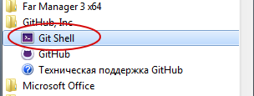

1. Generate key pair using ssh-keygen:

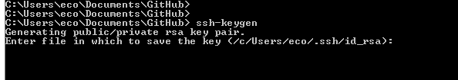

Remember file path (do not change it)

If asked for passphrase – leave it empty.

1. Open directory, where keys were saved and send file “id_rsa.pub” to me. It will be you public key. File “id_rsa” is your private key.
2. I will add your key to repository and then you will be able to use it (wait for confirmation until next steps).
3. Clone existing repository to current folder:

**git clone git@10.170.9.216:smartanalytics**

Folder “smartanalytics” will be created.

1. You can add this repository to GitHub Desktop app and work with it through GUI:

